RISK PARITY

Ian Lucas

Carrie Little

Shiley-Marcos School of Engineering – University of San Diego

AAI 500: Final Project Group 9

October 21, 2024

**RISK PARITY**

**Business Objective:**

As financial managers for Alcala Financial Advisors (AFA), we will analyze the client’s financial portfolio to ascertain its correlation and risk parity.

**Research Questions:**

1. What is the portfolio's current risk parity?

2. Should we rebalance the existing portfolio to maintain risk parity?

3. Should we add additional assets or classes of assets?

**Projected Project Timeline/Deliverables**

| Week 3 | 9/16/2024 | Form Teams, Choose Project/Dataset | Ian/Carrie |
| --- | --- | --- | --- |
|  | 9/21/2024 | In-Person Meeting, Create Collab Files/Folder | Ian/Carrie |
|  | 9/22/2024 | Formulate Research Questions | Ian |
|  | 9/23/2024 | Generate Business Objective | Carrie |
|  | 9/23/2024 | Review Dataset, Generate Data Descriptives | Carrie |
| Week 4 | 9/24/2024 | Outline Data Analysis Plan | Ian |
|  | 9/28/2024 | Develop Preliminary Models | Ian/Carrie |
|  | 9/28/2024 | In-Person Meeting, Analyze Models | Ian/Carrie |
|  | 9/29/2024 | Develop Conclusions and Recommendations | Ian/Carrie |
|  | 9/30/2024 | Submit Final Project Check-in | Ian |
| Week 5 | 10/1/2024 | Draft Report | Ian |
|  | 10/1/2024 | Draft Presentation | Carrie |
|  | 10/5/2024 | In-Person Meeting, Review Drafts | Ian/Carrie |
| Week 6 | 10/8/2024 | Review Tables/Figures/Visualizations | Ian/Carrie |
|  | 10/8/2024 | Review References/Sources/Links | Ian/Carrie |
|  | 10/11/2024 | Finalize Final Report | Carrie |
|  | 10/12/2024 | In-Person Meeting Presentation Rehearse | Ian/Carrie |
|  | 10/12/2024 | Finalize Presentation | Ian |
|  | 10/12/2024 | Record Project Presentation | Ian/Carrie |
| Week 7 | 10/21/2024 | Submit Final Report /Presentation | Ian |

**Dataset Overview**

Opportunity Dataset, Time based data

Dataset timeframe: 2014-11-30 to 2024-08-31 (‘Date’)

Downloaded from Portfolio Visualizer site: September 21, 2024

Rows: 118

Columns: 15

**Data Cleaning/Preparation**

Missing Values – Not Required

Data Consistency – 118 Months of Time-based Data for Each Asset

| Index | Assets | Count |
| --- | --- | --- |
| 0 | Vanguard LifeStrategy Income Fund (VASIX) | 118 |
| 1 | Vanguard Total World Stock ETF (VT) | 118 |
| 2 | PIMCO 25+ Year Zero Coupon US Trs ETF (ZROZ) | 118 |
| 3 | AQR Diversified Arbitrage I (ADAIX) | 118 |
| 4 | iShares Gold Trust (IAU) | 118 |
| 5 | Bitcoin Market Price USD (^BTC) | 118 |
| 6 | AQR Risk-Balanced Commodities Strategy I (ARCIX) | 118 |
| 7 | AQR Long-Short Equity I (QLEIX) | 118 |
| 8 | AQR Style Premia Alternative I (QSPIX) | 118 |
| 9 | AQR Equity Market Neutral I (QMNIX) | 118 |
| 10 | AQR Macro Opportunities I (QGMIX) | 118 |
| 11 | AGF U.S. Market Neutral Anti-Beta (BTAL) | 118 |
| 12 | AQR Managed Futures Strategy HV I (QMHIX) | 118 |
| 13 | Invesco DB US Dollar Bullish (UUP) | 118 |
| 14 | ProShares VIX Mid-Term Futures (VIXM) | 118 |

**Exploratory Data Analysis**

Statistics/Describe

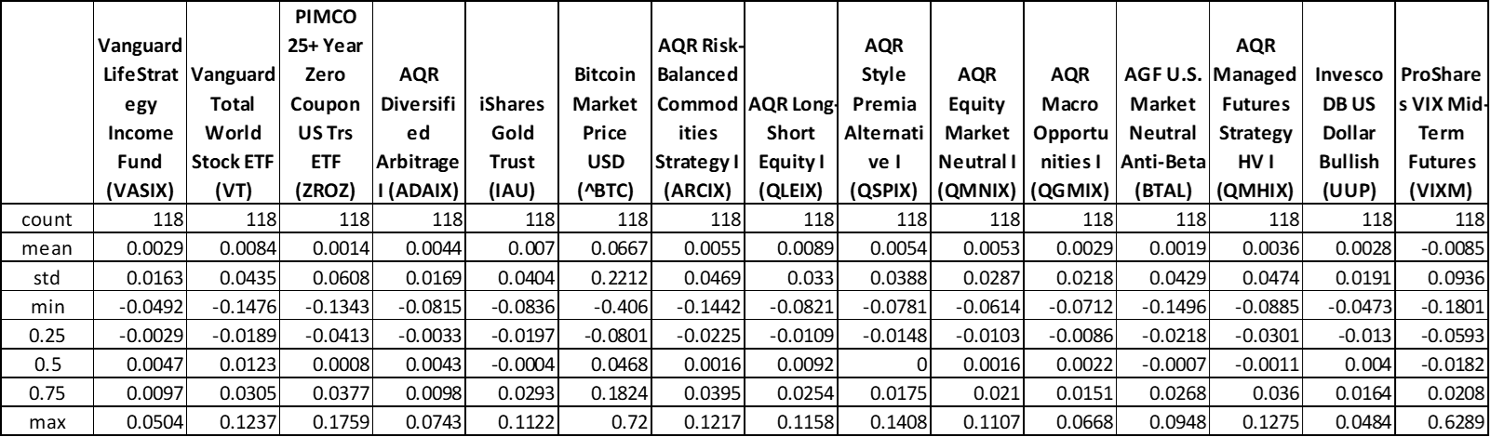

Numerical Attributes

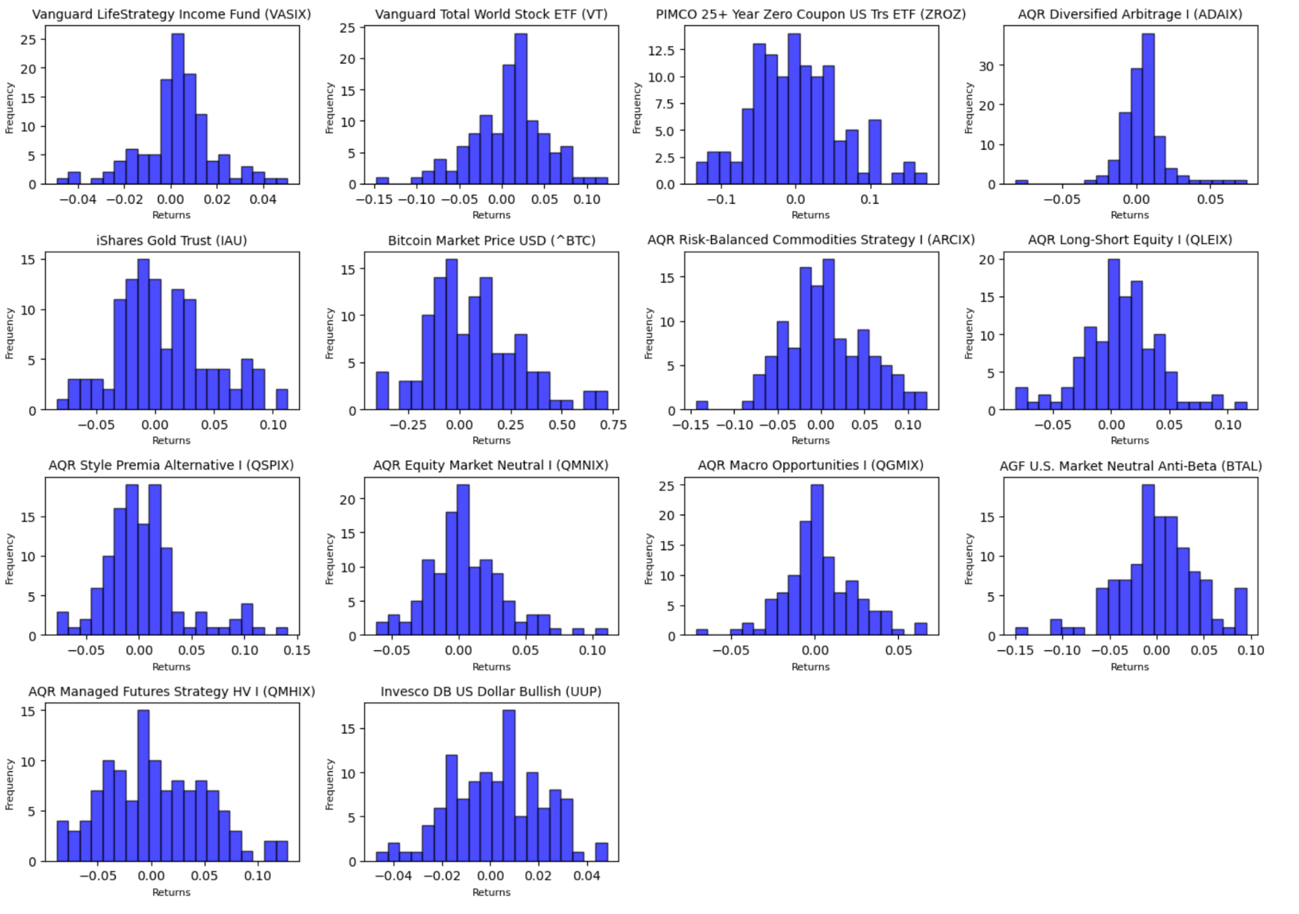

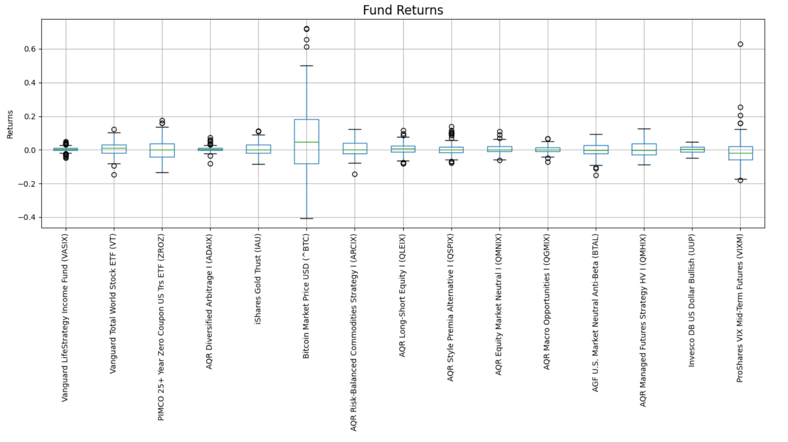

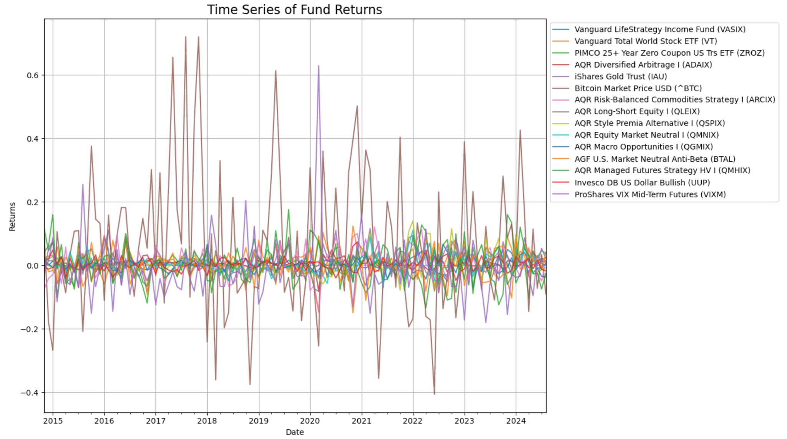

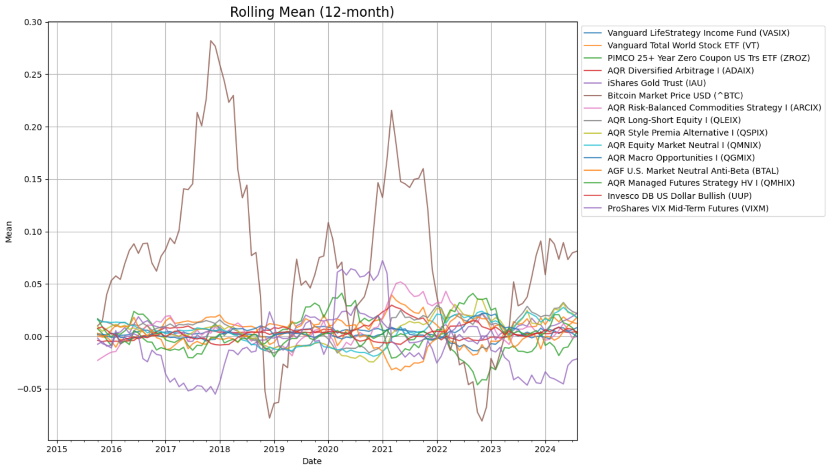

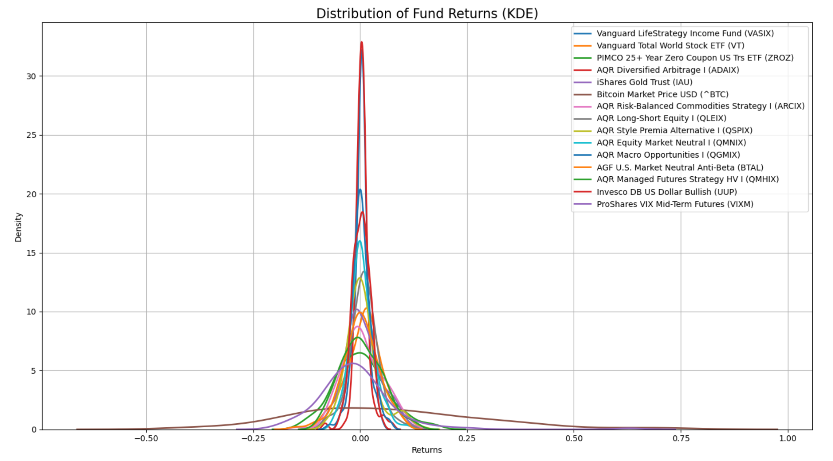

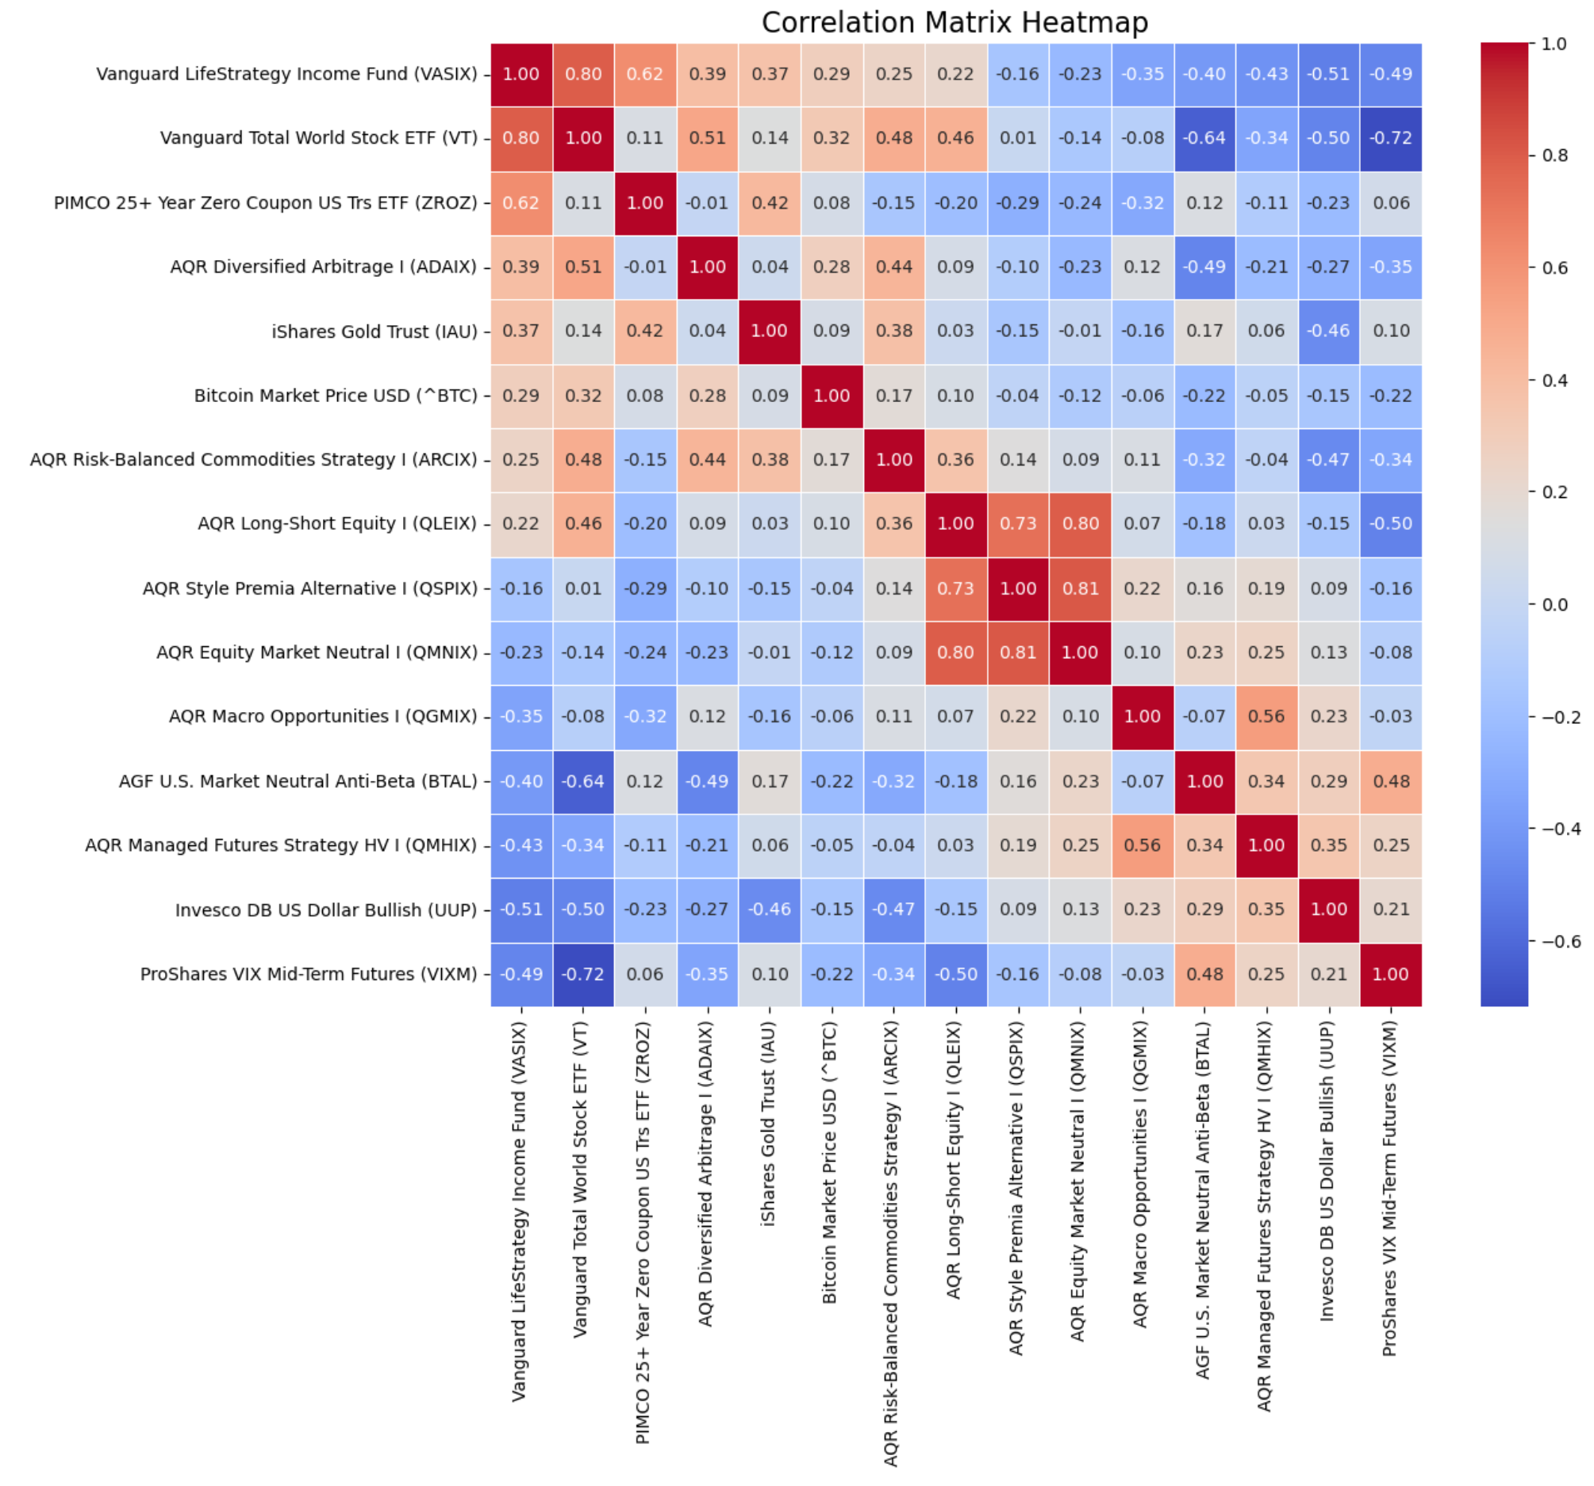

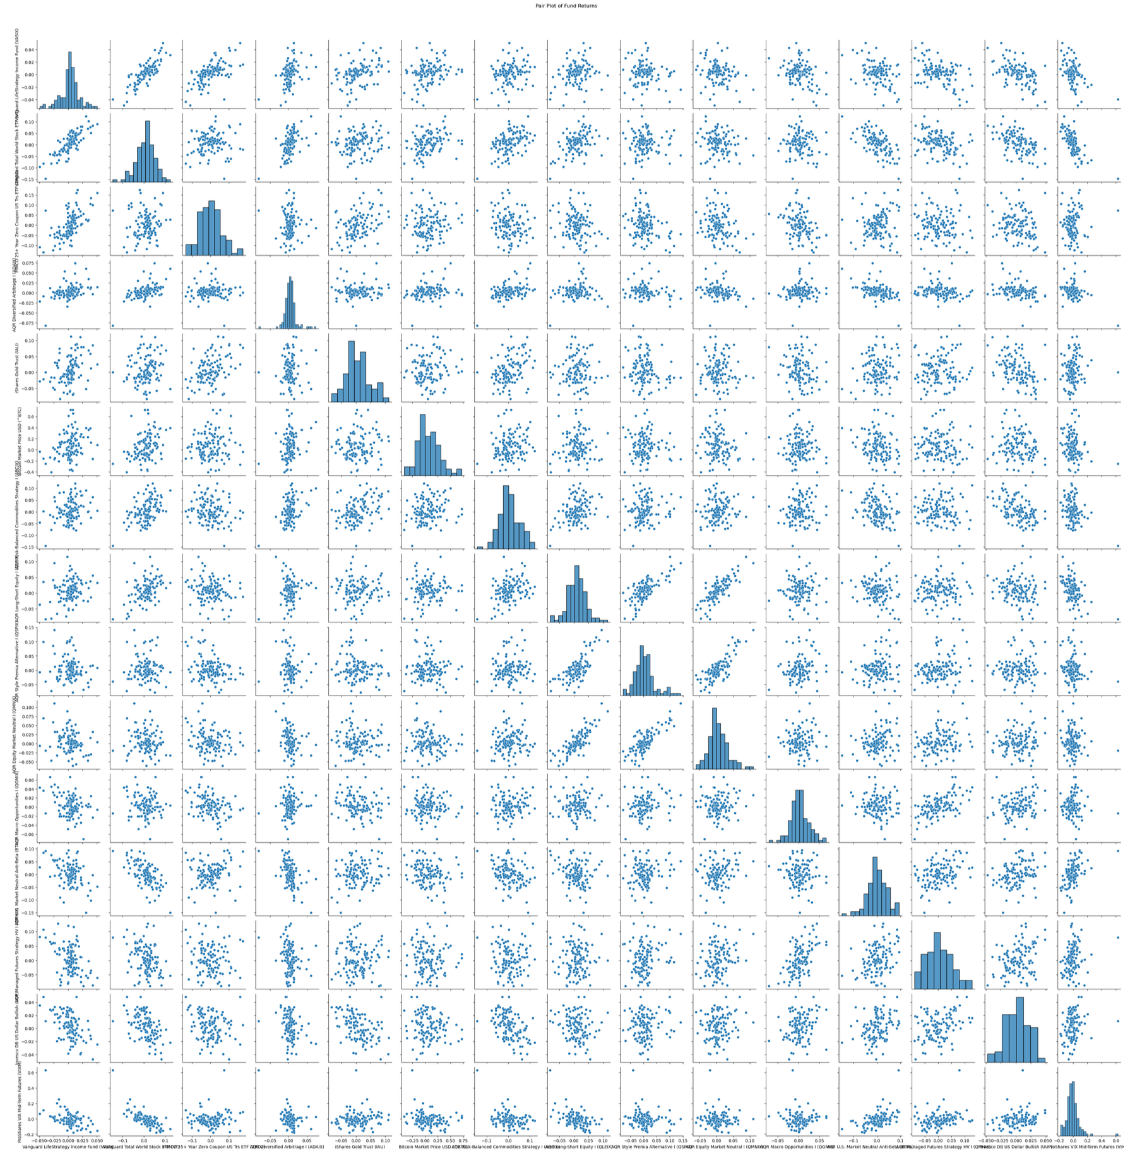

Categorical Attributes - None

**Model Selection**

Classification

Purpose: A classification model is used to predict categorical outcomes or discrete labels.

Output: The output is a class or label (e.g., "spam" vs. "not spam", "cat" vs. "dog").

Type of Task: Classification tasks are aimed at sorting data points into one of several predefined categories.

Logistic regression, Decision trees, Random forests, Support Vector Machines (SVM),

k-Nearest Neighbors (k-NN), Neural Networks for classification.

Regression

Purpose: A regression model is used to predict continuous numeric outcomes.

Output: The output is a continuous value (e.g., a real number like house prices, temperature, or salary).

Linear regression, Polynomial regression, Ridge regression, Lasso regression, Neural Networks for regression

**Model Analysis**

Standard Deviation/Error

P Values

**Conclusion and Recommendations**.

**References**